STOP SOLVING OTHER PEOPLE’S PROBLEMS
- Do you start your design by looking at themes(Bootstrap)?:
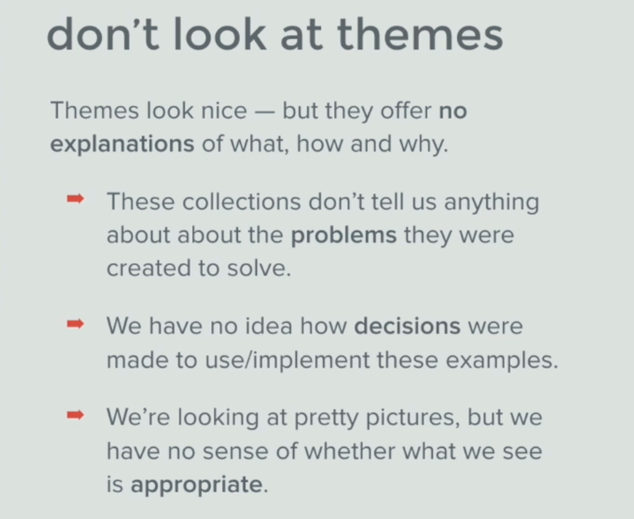
- Do you start the design process by looking at the work of other designers (Dribbble)?
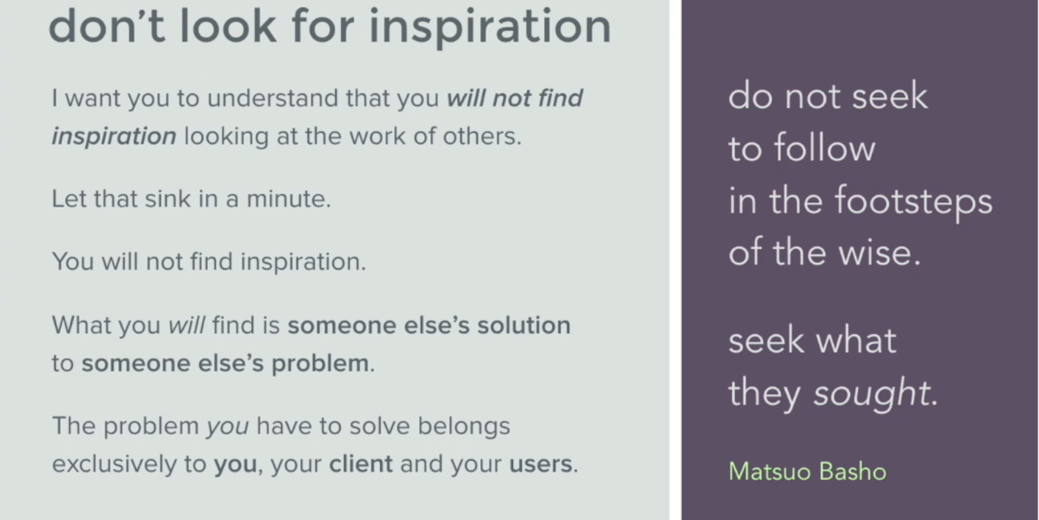

- How many of you start the design process by looking at current UI trends?
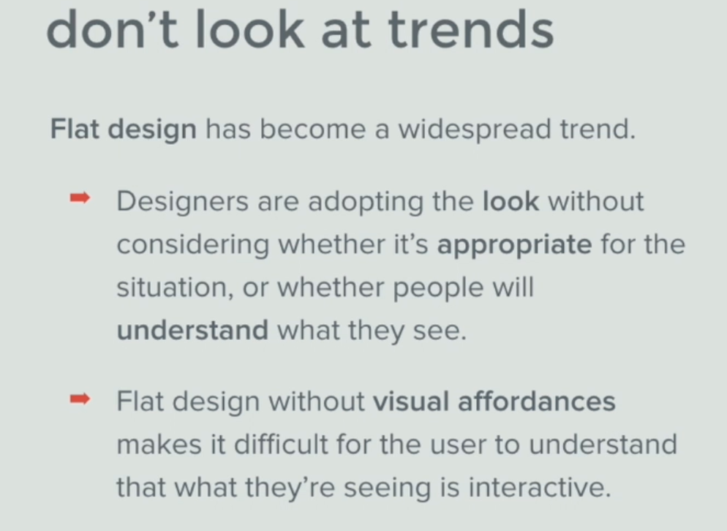
- Visual affordances are buttons, cues, symbols people are familiar with in their everyday life, for ease of use in a new design, people can’t appreciate what they don’t understand
- 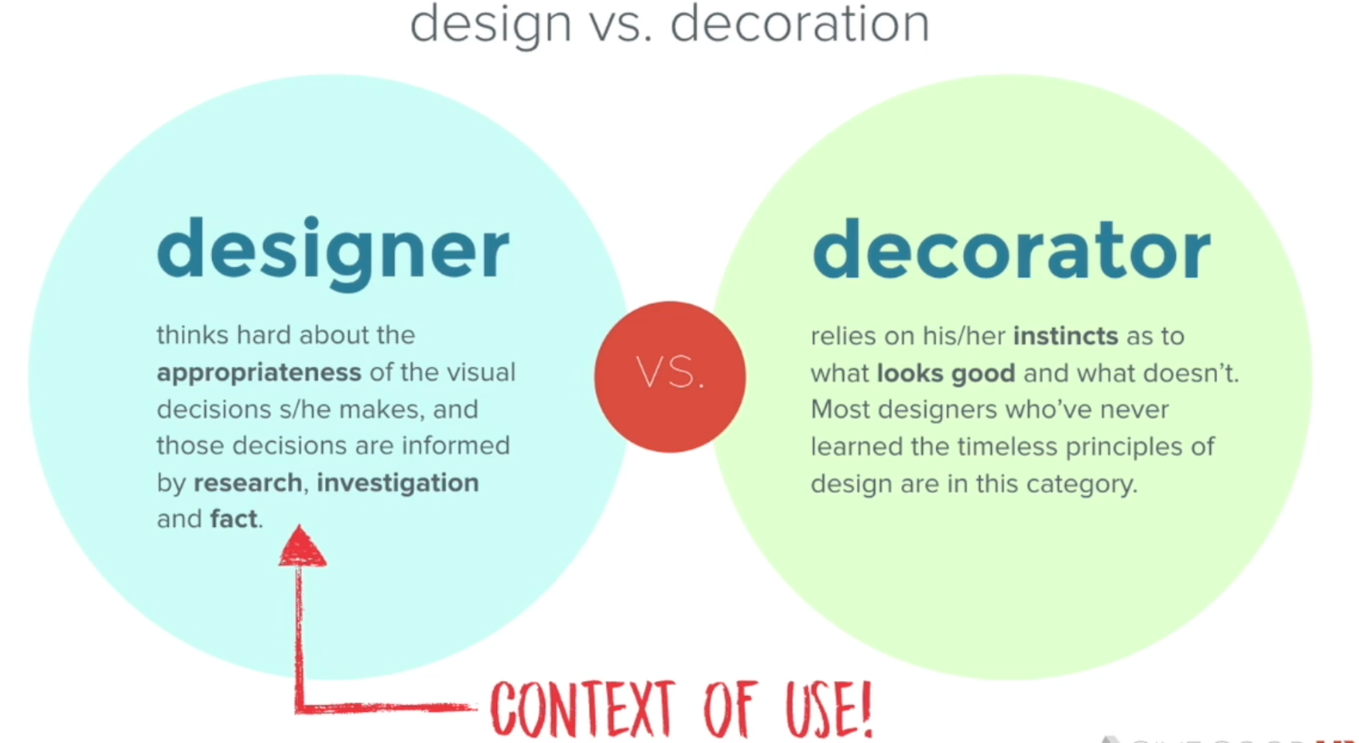
- Design mantra 02: stop solving other people’s problems, rather focus on your own problems you’re trying to solve, your clients, your product

